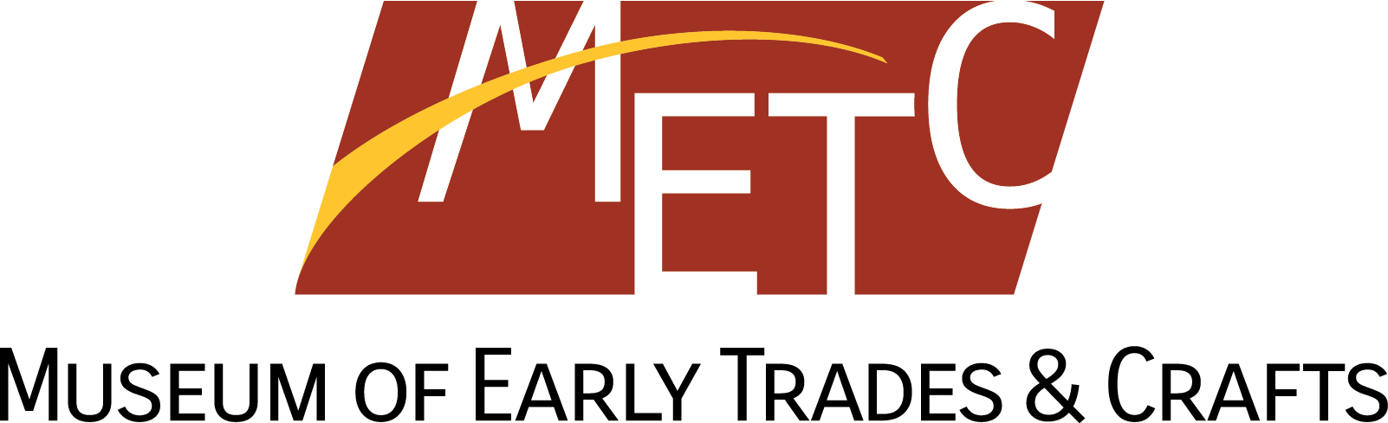

Share Your Story Project Release Form

By checking here, I hereby give authorization to METC for the use of my contribution to this Share Your Stories Project with the understanding that:

- My submission may be made available to researchers upon my review and approval Responsibility for reproduction, distribution, display, and the creation of derivative works lies with The Museum.

- I agree that The Museum may use and reproduce my submission in other media (such as film, exhibition, and/or website) at their discretion.

- I hereby grant, assign, and transfer to METC all rights of copyright in and through all media, print, electronic and otherwise, except that I shall retain the right to copy, use, and publish my own work in part or in full.

- This agreement contains our entire and complete understanding.

- I am 18 years or older.

_________________________________ _________________________________

Name Name and Title of METC Representative

_________________________________ _________________________________
Signature of Individual METC Representative Signature

_________________________________ _________________________________
Date Date

